Glastonbury Martin Luther King Community Initiative re-ups celebration of MLK
By Steve Smith
Hartford Courant

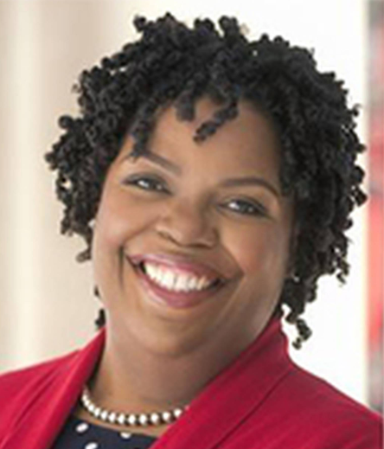
Dr. Tekisha Dwan Everette, executive vice president of Trust for American’s Health, a health policy advocacy organization, will be speaking about healthcare inequities at the event. (Courtesy Photo)

Glastonbury — After several years of hiatus, a big, birthday celebration of Dr. Martin Luther King, Jr. is returning to Glastonbury, on Jan. 15.
The Glastonbury Martin Luther King Community Initiative previously held celebrations of King’s life and legacy each year, near or on his birthday. That type of event hasn’t happened since 2016, as the group put more focus on it’s well-received and well-attended community conversations that each focused on a topic such as immigration, systemic racism, healthcare, and most-recently, organized labor.
As in the past, the celebration will be held at Smith Middle School, beginning at 3 p.m.
GMLKCI member and event chair Darwin Kovacs said it was felt that it’s time to expand, draw more attention to King, and bring more people together.
The program includes the Glastonbury High School Concert Choir, who will be performing “Daniel, Daniel, Servant of the Lord,” “Walking on that Heavenly Road,” “Let There Be Peace on Earth,” and “Lift Every Voice and Sing.”
A film, produced by students in Simsbury, about the time King spent working in tobacco fields in Connecticut (during the summers of 1944 and 1947) will also be shown.
GMLKCI member Dick Allen, former pastor of the South Congregational Church, will read an essay he wrote.
Speakers will include Dr. David Williams and Dr. Tekisha Dwan Everette, who will address the topic of Health Disparities: the Racial, Economic, Cultural and Social Causes. King addressed this inequity in 1966, saying, “Of all the forms of inequality, injustice in health care is the most shocking and inhumane.”

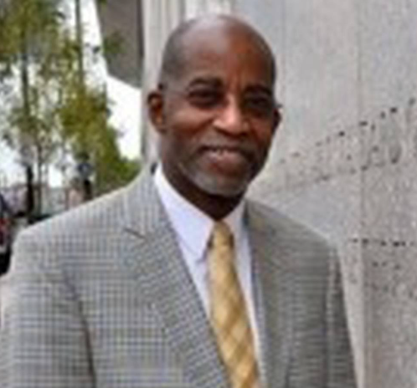
Dr. David Williams is one of the speakers who will address the topic of healthcare inequities. (Courtesy Photo)

Williams is a professor at Harvard and an internationally recognized social scientist focused on social influences on health. Everette is the executive vice president of Trust for American’s Health, a health policy advocacy organization.
“The reason we chose this topic is because we saw many articles, including in the Hartford Courant, about health disparities - black women dying more after childbirth than white women, infant mortality is higher - those kinds of stories are pretty frightening,” Kovacs said.
Several local organizations will have tables set up in the cafeteria at Smith Middle School, hoping to find new members and/or make other connections.
“We hope that the speakers will give us a call to action,” Kovacs said. “We know there are people in town who want to do something, but don’t necessarily know what to do.”
This is a free event open to all. For additional information, visit www.glastonburymlkci.org.

