Gun Control Discussed At Conversation In Glastonbury
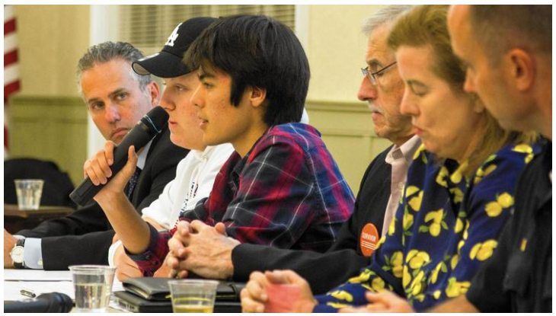
Tommy Murray, co-chairman of the Junior Newtown Action Alliance, told the story of what it was like to be a sixth grader in Newtown on Dec. 14, 2012. (Steve Smith/Courant Community)
Steve Smith Staff Writer
On Sept. 24, the Glastonbury Martin Luther King Community Initiative held a community conversation titled "Gun Violence: Can It Be Reduced?" at the Riverfront Community Center.
Some of the key points were that voting is the best path to creating change, and that getting youth involved may be the long-term answer.
Featured speakers included Tommy Murray and Jackson Mittleman, both of whom were sixth graders at different schools in Newtown on the day of the shooting at Sandy Hook that took the lives of 26, including 20 first graders. The two, now Newtown High School seniors, are co-chairs of the Junior Newtown Action Alliance, which has been lobbying in Washington, D.C. for gun control, among its efforts.
"We were in lockdown all day," Murray said. "I was in the gym for hours. That's when we heard that some incident had happened at Sandy Hook. When I got home, my sister was waiting outside, and was crying. When I went inside... and saw the news, and realized that 26 students and teachers were killed."
Murray was a neighbor of Adam Lanza , but did not know him well.
"It was just shocking," he said.
Murray's mother started the Newtown Action Alliance. His sister and her friend started the Junior Newtown Action Alliance.
"Basically, for the past few years, we've been trying to engage more people into helping fight gun violence," Murray said. "We're trying to gain as much support as we can, because we think that stricter gun laws are important for keeping the guns out of the hands of criminals. We think that background checks are needed at the federal level."
Murray said that support has grown after the shooting at the Stoneman Douglas High School in Parkland, Florida, on Feb. 14 of this year.
"I think now that we have more students engaged, I think we can push Congress," Murray said. "We need to push more people to vote, as well. That's also important for passing laws. If we can't push Congress to do what we want, we need to vote them out."
Mittleman said he learned of the shooting from his father, who picked him up at school early on Dec. 14, 2012. He said that just as shocking was the effect on the students and the town in the days, weeks, and years after the shooting. He joined the Alliance in seventh grade, and thought that the group's effort would have more of a result.
"We have more than 150 students currently involved with the club," he said. "We've been working so hard over the last five years. We're not stopping until we get some laws passed in Congress. The debate on ending gun violence is not about whether you like guns or you don't, or whether you use guns or you don't. It's about whether you'd like to live or not."
Other panelists agreed that the best way to reduce gun deaths is by pushing for better gun control legislation.
"Gun laws do work, and the stats show that. Gun violence can be reduced, and it takes legislation. It's about votes," said Jeremy Stein, executive director of CT Against Gun Violence. "If you want to pass a law, you have to have the votes. It's about who is going to vote in favor of that, and the only way that's going to happen is you have to vote for elected officials who are going to vote the way you want them to vote."
"The cultural change that we're experiencing now will change the future," said Tom Campbell, president of the Greater Danbury Brady Campaign. "The youth will lead us. Sometimes, it takes a generation for us to get through some of these issues, like it did with same-sex marriage."
Glastonbury Police Chief Marshall Porter, who has been in Glastonbury just about a year, said that while Glastonbury is a relatively safe community, it does have a stake in combating gun violence.
"We are not immune to gun violence. Since I've been here, guns have been stolen in burglaries from houses, we've had gun suicides, we've had officers remove illegal weapons from people they've arrested who are not supposed to have weapons," he said. "So, the potential is here. Gun safety is a top priority of mine."
Porter said that discussions like the one in which he was taking part are a step in the right direction.
"It all really starts with what's happening here - gathering together, airing our concerns, and coming together as a community to try to find some answers," he said.
The GMLKCI had also reached out to other groups, including the National Shooting Sports Federation, the Coalition of Connecticut Sportsmen, Connecticut Carry, the Connecticut Citizens Defense League, Stag Arms, Colt Manufacturing, Standard Manufacturing and the Connecticut Shotgun Manufacturing Company, to take part in the discussion. All but the last did not even respond to the request.
For more information, visit www.glastonburymlkci.org

