Glastonbury group planning conversation on affordable housing

**By**[**STEVE SMITH**](https://www.courant.com/hc-steve-smith-staff.html#nt=byline)

HARTFORD COURANT | MAY 06, 2021 AT 1:12 PM

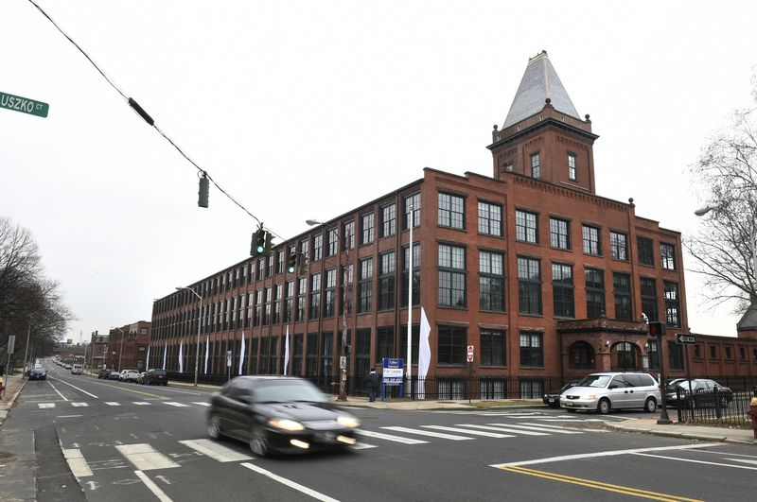

The conversation will look at the history of housing segregation, zoning issues, and myths surrounding affordable housing. (Cloe Poisson / Hartford Courant)

GLASTONBURY — The Glastonbury Martin Luther King Community Initiative (GMLKCI) is planning its next in its ongoing series of community conversations, for May 10.

The conversation, titled “Affordable Housing: Myths, Benefits and Solutions,” will be held virtually from 7 to 8:30 p.m., via Zoom. The event is jointly sponsored by the Open Communities Alliance and Truth in Action with Love and Kindness, Inc. (TALK).

This conversation is the second in a series of three on the topic. The first was held by TALK in March, and focused on the Fair Share model for apportioning the region’s affordable housing need among the towns in the region, based on their resources and financial capacity. A third talk on housing will be hosted by TALK and OCA, on June 1.

David O’Connor, co-president of GMLKCI, said the talk is very timely, as the Town of Glastonbury is forming a steering committee to look at changing housing needs and affordable housing in Glastonbury, as required by recently passed state legislation (CGS Section 8-30j). The statue requires the town to adopt an affordable housing plan by June of 2022, and enact new zoning regulations. “There’s a lot cooking in this area,” O’Connor said.

Guests for this event will include Glastonbury resident Erin Boggs, executive director of OCA; Sam Griffin, OCA policy and data analyst; and Taniqua Huguley, OCA’s outreach director.

The conversation will look at the history of housing segregation, zoning issues, and myths surrounding affordable housing. “There’s concern that having more people come into the community is going to increase school [population], and crime is going to go up,” O’Connor said. “These are the sort of concerns in neighborhoods where people try to create obstacles to affordable housing. There’s data to show that these are not true - that crime doesn’t go up, and the benefits way outweigh any consideration of the downside.”

The panelists will also talk about solutions and paths for the future. “What to do to move forward, to try to provide more affordable housing opportunities, particularly in Glastonbury,” O’Connor said. “This is something that TALK has been working on for a couple of years - to try to build support for affordable housing and for a potential project in town.”

Attendees at the virtual meeting will be able to ask questions via the chat function, throughout the conversation.

For additional information, visit [**https://glastonburymlkci.org/**](https://nam02.safelinks.protection.outlook.com/?url=https%3A%2F%2Fglastonburymlkci.org%2F&data=04%7C01%7Cssmith%40courant.com%7C6c8a50621b3448884f7908d90349b6b7%7Cf7da0482aed242fa80233b240fb6598d%7C0%7C0%7C637544437548472701%7CUnknown%7CTWFpbGZsb3d8eyJWIjoiMC4wLjAwMDAiLCJQIjoiV2luMzIiLCJBTiI6Ik1haWwiLCJXVCI6Mn0%3D%7C1000&sdata=y0I9K%2BxjViv%2BGtH%2BQnRAbvuGihkPhUFksdrrM3z482o%3D&reserved=0) or call 860-810-2368.

To register, log onto the Glastonbury MLK Community Initiative web page and click on “Register” or paste the following link into your browser: [**https://tinyurl.com/5em7pe9x**](https://nam02.safelinks.protection.outlook.com/?url=https%3A%2F%2Ftinyurl.com%2F5em7pe9x&data=04%7C01%7Cssmith%40courant.com%7C6c8a50621b3448884f7908d90349b6b7%7Cf7da0482aed242fa80233b240fb6598d%7C0%7C0%7C637544437548482697%7CUnknown%7CTWFpbGZsb3d8eyJWIjoiMC4wLjAwMDAiLCJQIjoiV2luMzIiLCJBTiI6Ik1haWwiLCJXVCI6Mn0%3D%7C1000&sdata=C4XHfXzdlPL8LbKLKeqemAMVyGG6o5uJKgPr1wTI1FQ%3D&reserved=0).