Incarceration And Racial Inequity Discussed

**[[Steve Smith](https://www.courant.com/hc-steve-smith-staff.html)](https://www.courant.com/hc-steve-smith-staff.html)**

By [STEVE SMITH](https://www.courant.com/hc-steve-smith-staff.html#nt=byline) HARTFORD COURANT | GLASTONBURY

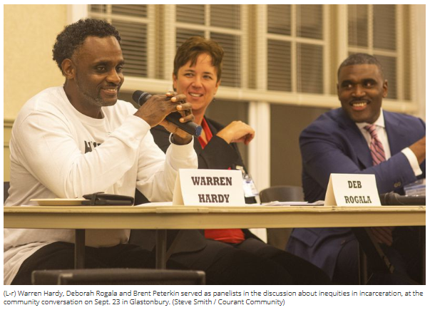

The Glastonbury Martin Luther King Community Initiative held a community conversation titled “Mass Incarceration & Reformatory Justice; Changing Perceptions, Providing Opportunities, Advocating Reform,” on Sept. 23 at the Riverfront Community Center.

Keynote speaker and moderator Rev. Gordon Bates said that the prejudice in the criminal justice system, and any prejudice, is rooted in the fear of the “other.”

“It’s still part of us - part of our DNA,” Bates said. “It’s part of what lies behind so many of our problems today.”

Bates said that while laws haven’t always been on the side of justice or equality, including how mass incarceration is essentially a legal form of slavery, the good news is that Connecticut has long been a model of progressive corrections.

“Connecticut has closed institutions of corrections - from 22 down to about 12,” Bates said. “We’ve reduced the number of offenders incarcerated on the adult level, from about 20,000 in 1965 to less than 12,000 now. We’ve reduced many of the assumptions that have gone into sentencing, and we’ve moved into more progressive laws.”

Panelists included Warren Hardy, a former Hartford gang member, who after serving six years for a racketeering charge, has volunteered in organizations focused on educating young men about the dangers of gang activity.

He is now a Support Specialist with My People Clinical Services (MPCS), which was established to “Support, Empower, and Rebuild” the lives of individuals and families in the Greater Hartford area by meeting their social and mental health needs.

Hardy said that growing up in violent areas, like those in Hartford, creates traumas in young people that are typically not addressed, and have long-term effects on mental health, which leads to more crime.

“There were a lot of systemic issues that played huge roles in my growing up in Hartford,” Hardy said, adding that gang members and other violent people are acting from a place of hurt. “They’re acting hard, but they’re really hurting, and they need some healing. If we can provide the healing, and that means put ourselves in those uncomfortable situations so we are not talking about ‘the other’ but talking about ‘us,' as human beings. That requires some sacrifice. So many of us don’t want to have that conversation. The truth is, the reason why the other is there... is somebody has to benefit.”

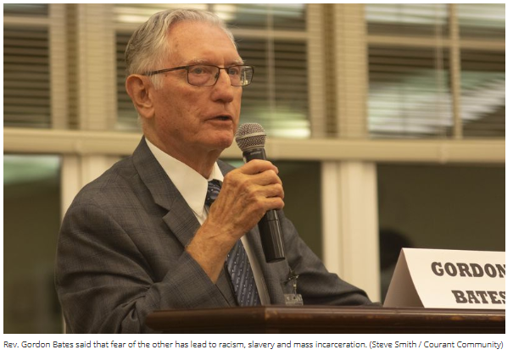

Deborah Ragala, clinical program operations director (POD) with Community Partners in Action (CPA), a nonprofit criminal justice agency that has been in existence since 1875, said that her work in the reentry field has shown that many times, people who live in poor areas, or even more-densely populated areas, are penalized more severely for the same crime.

Expanding on an issue mentioned by Hardy, Ragala said that drug possession charges are more severe when the person is found within 1,500 feet of a school, but since schools are more numerous and closer together in more populated areas, more urban residents are receiving longer sentences or harsher penalties.

“Most likely, if you’re in Hartford, you’re going to jail for whatever the minimum is, because there aren’t very many areas where you’re not 1,500 feet from a school,” Ragala said. “Think about Glastonbury, Avon, West Hartford. The same, exact crime, you will not serve time. That’s unjust. That’s incarcerating a certain population.”

Brent Peterkin, the statewide director for Project Longevity, an organization which marshals law enforcement agencies and communities to focus on gun violence, said that once a community is labeled as a violent community, smaller crimes are dealt with more harshly and more often.

“Is the entirety of Hartford riddled with violence? Is the entirety of Hartford riddled with drug sales? No. Most of those people are hard-working citizens of this state who are just trying to get by, make ends meet, raise their children, and provide for their families," Peterkin said. “What happens is, through a political lens and social lens, we label entire communities, and then try to throw a fire blanket over entire communities.”

“The entire community is targeted,” Peterkin added. “Minor crimes and infractions - it can be trespassing or disorderly conduct - all of these small charges, seemingly trivial charges, put you in the system. You get a record as a result of this activity.”

Being proactive and leading by example, Hardy said, are the ways to improve lives and reduce incarcerations.

Hardy organizes community barbecues in the most troubled areas of Hartford on a regular basis, to try to bolster the community spirit, but also provide an example for younger people.

“Young people are being traumatized daily,” he said. “In those areas, there are a lot of people who are children... who don’t have the luxury of saying, ‘I don’t want to be here,’ because it’s where they live. The only way is to bring light to these same babies that will grow up - learning what they are seeing, and nine times out of 10, they’re going to be growing up doing the same things. That’s why we are going out in the communities and bringing light. It only takes one time in your life being enlightened and you never forget it."

Attendees were urged to talk to legislators and get involved to create change.

“I would like you to take the most salient parts of this conversation to your legislators,” Peterkin said, adding that one can also align oneself with advocacy organizations.

“Find what you’re passionate about and authentic about in what you heard tonight, and share it with others. Knowledge of what is really happening is so critical,” Ragala added.

For more information, visit **http://glastonburymlkci.org/**