Healthcare Talk Takes Aim at Costs

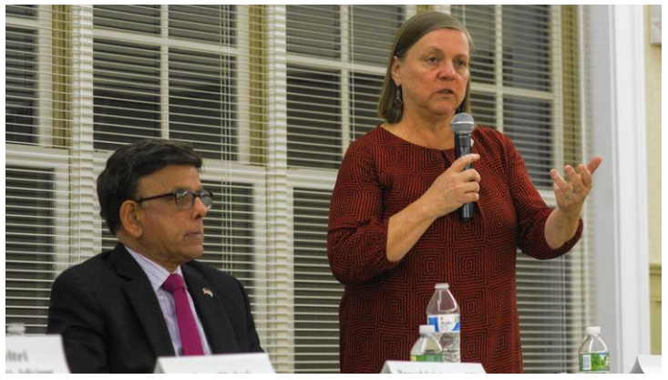
State Rep. Prasad Srinivasan listens as Lynne Ide, the director of Program and Policy at the Universal Healthcare Foundation of CT, speaks at the Community Conversation on Healthcare on Nov. 1. (Steve Smith/Courant Community)
Steve Smith Staff Writer
A community conversation about healthcare shed some light on where the problems lie with the current state of the healthcare system.

At the Glastonbury MLK Community Initiative's Community Conversation: "Healthcare - A Right or A Privilege?," held on Nov. 1 at the Riverfront Community Center, much of the conversation pointed toward rising medical costs as the No. 1 factor for increasing health insurance premiums, larger deductibles, and out-of-pocket expenses.

Panelist James Wadleigh, the chief executive officer of Access Health CT and a Glastonbury resident, said that the Affordable Care Act has been successful, with more than 2 million state residents coming to Access Health seeking health insurance - lowering the uninsured rate in the state from 12 percent to about 4 percent.

Wadleigh said that his office has been focusing on what it can control, while dealing with the changes in healthcare. The "repeal and replace" effort has caused a lot of confusion.
"Our organization is constantly taking phone calls from people who think they do not have to purchase health insurance, or that they don't have financial help," he said. "The Affordable Care Act is still, legislatively, the law."

Jason Madras is the vice president for Connecticut at Harvard Pilgrim Healthcare, a not-for-profit insurer that recently started working in Connecticut, but has been operating in Massachusetts, New Hampshire, and Maine for many years.

Madras said that his organization has had to raise its costs, not to increase profits for shareholders, but to keep up with the cost of the medical treatments.

"When we are getting our premiums determined for a calendar year, it's almost all the cost of the physical care," he said. "It is directly related to the cost of the care that you receive. If we don't, as a state and as a country, come together to address the massive 800 pound gorilla in the room, which is the underlying cost of care, we're basically going to be putting window dressing on a house that's on fire."

Madras said that when renegotiating contracts with medical providers, the rates have been going up each year by an average of 10 percent for the past several years.

"Sometimes, it's for the same procedure in the same hospital, with the same doctor and the same tools…," Madras said. "I'm not sure why they've gone up 10 percent, but they've gone up 10 percent."
State Rep. Prasad Srinivasan, a practicing physician, said that healthcare, which is already 17.5 percent of the country's gross domestic product (GDP), could reach 25 percent by 2025. Containing the healthcare cost, he said, should be a priority.

"If we do not contain that, and that becomes a train wreck, access will be impaired and quality, unfortunately, is going to be compromised," Srinivasan said.

There have been some efforts, meeting with some success, at mitigating those costs.
Victoria Veltri, the chief health policy advisor in the office of Lt. Governor Nancy Wyman, said that the rising costs have been happening long before the Affordable Care Act, which some people mistakenly choose to blame, and that the ACA has actually slowed the costs some.

Veltri said that the state's newly-created Office of Health Strategy is working on bringing together data (from hospitals, including rates of utilization and financial data) that will help form new, fact-based policy.

The goal, Veltri said, is to bring all of the different payers in the state, including commercial, Medicaid, and Medicare, to shift the discussion from paying for each provider visit to a value-and-outcome based system.

"We pay every time there's a visit, and we don't really ask about quality," Veltri said, adding that the initiative will strive to make quality a part of healthcare by rewarding providers for a good track record, and work with those who need improvements.

"That's one way we will be able to contain costs," Srinivasan said. "That's a logical way for us to move - in the direction where we look at outcomes."

Perhaps the best reducer of medical costs is prevention.

"We don't pay providers to prevent illness, we pay them to treat people," Veltri said. "We have a 'sick system.' We have to switch our thinking and try to get ourselves to a 'health system.'"

Kate McEvoy, the director of the Division of Health Services at the Department of Social Services, said that the State of Connecticut has been able to demonstrate that the Affordable Care Act has helped wellness and reduced costs by providing better preventative care.

"We've seen each of those demonstrated, empirically, in indicators that we have been able to prove out, over seven years," she said. "We've also been able to demonstrate, over that time, that we've had a reduction in the per-member, per-month costs, for individuals on Medicare, because we have better supported their needs, and better-coordinated their care."

Lynne Ide, the director of Program and Policy at the Universal Healthcare Foundation of CT, said her office advocates for quality healthcare for everyone.

"Our system is unsustainable, as it is," Ide said, adding that cost containment will have to come from the voices of the consumers, because the problem is a lack of political will.

"We can't be spending 18 to 20-percent of our GDP and getting worse results than every industrialized nation in the world, as far as health outcomes, and expect that to be sustainable," she said. "If we are spending that percentage of our money on healthcare, what is that taking away from? It's about time that people like you, who are getting squeezed by all of this, stand up and take some action."

For more information, visit www.glastonburymlkci.org.

