Glastonbury's Housing Future Discussed

By Steve Smith
Hartford Courant Staff Writer

Can Glastonbury's housing change with the current and predicted trends? What the town would have to do to become more diverse in its housing was part of the discussion at a Community Conversation, held by the Glastonbury Martin Luther King Community Initiative, in collaboration with the Open Communities Alliance, on March 30.

Glastonbury resident Erin Boggs, who is also the Director and founder of the Open Communities Alliance, said the evidence is pretty clear as to what the demographics of the region are going to look like in the future, and that Glastonbury has a chance to "get ahead of that, and think a little bit about how we can incorporate the new way our median is going to look, and the things we love about our town, and how we can pull them together for a strong, vibrant Glastonbury community for our future."

"I'm hoping that we might move, just a little bit, toward looking outside of the boundaries of Glastonbury itself," Boggs said. "There's really a greater need for housing some groups that we may not see the need for housing here in Glastonbury."

Orlando Rodriguez, a demographer with the Latino and Puerto Rican Affairs Commission, showed the trends in the population, which shed some light on the changing face of homeowners and renters.

School enrollment is declining in Glastonbury and in Connecticut at large, as well as most of the country. Rodriguez said that projections show that continuing through 2025, when Glastonbury can expect as much as 20-percent fewer students as it has currently. More families are single-parent families, and that translates to significantly lower incomes.

Ethnically, the Hispanic population of Connecticut will double from 9-percent to 20-percent, while the Asian population will also grow and the African American population will hold steady. However, unemployment is higher among non-whites, and the median income also varies with race.

"In Connecticut, the median income is around $84,000." Rodriguez said. "If we look at non-Hispanic whites, it's over $90,000, and if you look at Hispanics it's half of that."

The population of retirees is also increasing.

"What's going to follow the growing elderly population is their income and disability status," Rodriguez said. "Not everyone who retires has high income. Right now, the state has a program where local property taxes are reduced for households below a certain income level. That number is going to increase by 57-percent by 2025."

Professor Jack Dougherty, a professor at Trinity College, showed some interesting history about how housing was segregated by design in the Hartford area, and how those standards have shaped many towns, who have inherited the housing barriers of the region.

In the 1930s and 1940s, there were government-supported racial barriers, Dougherty said, citing zoning laws in West Hartford that were written into the deeds of homes in some neighborhoods.

"No persons of any race except the white race shall use or occupy any lot except that this covenant shall not prevent occupancy by domestic servants of a different race employed by an owner or tenant," Bougherty said (citing the code), adding that while the U.S. Supreme Court ruled such rules "unenforceable" in 1948, many of them are still on the books, "and they still have a lasting influence today."

Exclusionary zoning, Dougherty said, has taken other forms over the years, including neighborhoods that exclude multi-family homes.

"You get a color-blind law, that's not overtly racial, but it excludes lower-income families, and by consequence, perpetuates a racial divide," Dougherty said.

After the presentations, a panel was asked about what Glastonbury would have to do to make affordable housing more available.

"It's a big, complicated issue," said Whit Osgood, Vice-Chair of the Glastonbury Town Council. "It's one that the town of Glastonbury has been trying to address for many years."

Neil Griffin, Executive Director of the Glastonbury Housing Authority, said his agency looks at reports and information like those presented, when it makes its decisions.

Griffin said that most of the agency's 412 units are 40-years-old, and there is currently a focus on renovations, but that there is also a close eye on demand.

"Is there a great demand for those units," he said. "Is there an oppportunity for us to look to increase the number of units we have because of that demand?"

Funding is also important, and sources include state and federal funds, as well as the rents collected.

"We've been very fortunate in Connecticut, that the state funding stream has been phenomenal," Griffin said, adding that the federal funds haven't been as good. Demographics, Griffin said, are also considered.

"We try to stay ahead of that," he said, "to make sure we're in position to have the housing available for that population, as we see it coming to us."

Osgood said that if the state raised the section 8 funding, much more would be possible.

"I think the state subsidies go a long way to make these sites possible," Osgood said, adding that the town could also allow higher –density and multi-family units in more areas would help.

"From the municipal side, the largest thing the town can do is to make sure their zoning ordinances can permit this type of development."

John Selders, Pastor at the Amistad United Congregational Church in Hartford, said that to affect real change, Glastonbury first has to ask itself if it really wants to be diverse.

"Cities like Glastonbury were created to be a certain kind of way," Selders said. "They continue to maintain that certain kind of way. I'm used to coming to these kinds of places and being one of a few…racially and ethnically."

"One thing we to think about is whether Glastonbury is a welcoming community," Boggs said. "We need to drill in to that and determine whether that is a problem across the board, and dig down and determine what can be done."

Going forward, Selders said, will require towns like Glastonbury to take a good look at itself and determine what it really wants to be.

"We need to talk about, in a peaceful way, but not just talk about it, do something about it," Selders said. "This town is not very diverse, racially and ethnically. There are reasons why that is a truth. Own it and tell the truth about it, before we start talking about building other things. If you want diversity, then we need to have that conversation, and not just about how comfortable you are [with people of color] interpersonally."

For more information, visit www.glastonburymlkci.org.

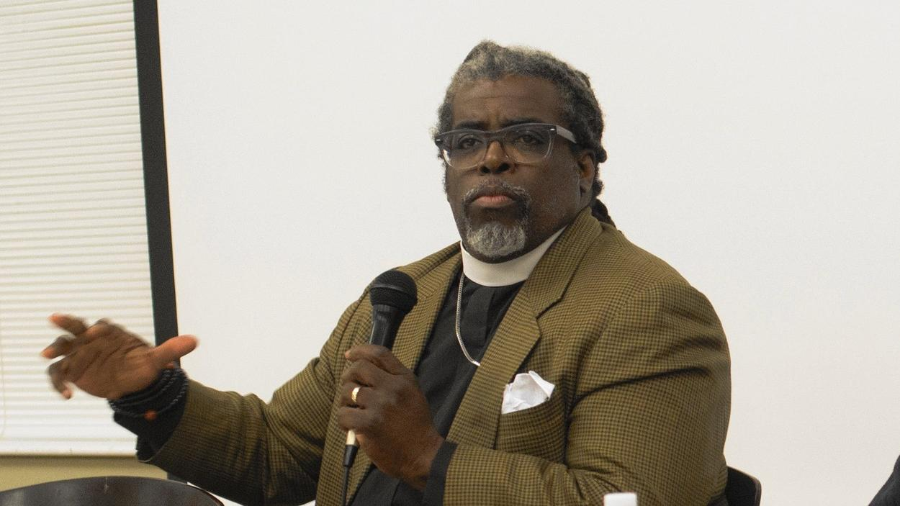

Glastonbury Town Council Vice-Chairman Whit Osgood (right) listens as Bishop John Selders of the Amistad United Church of Christ speaks at the Community Conversation held by the Glastonbury Martin Luther King Community Initiative on March 30.

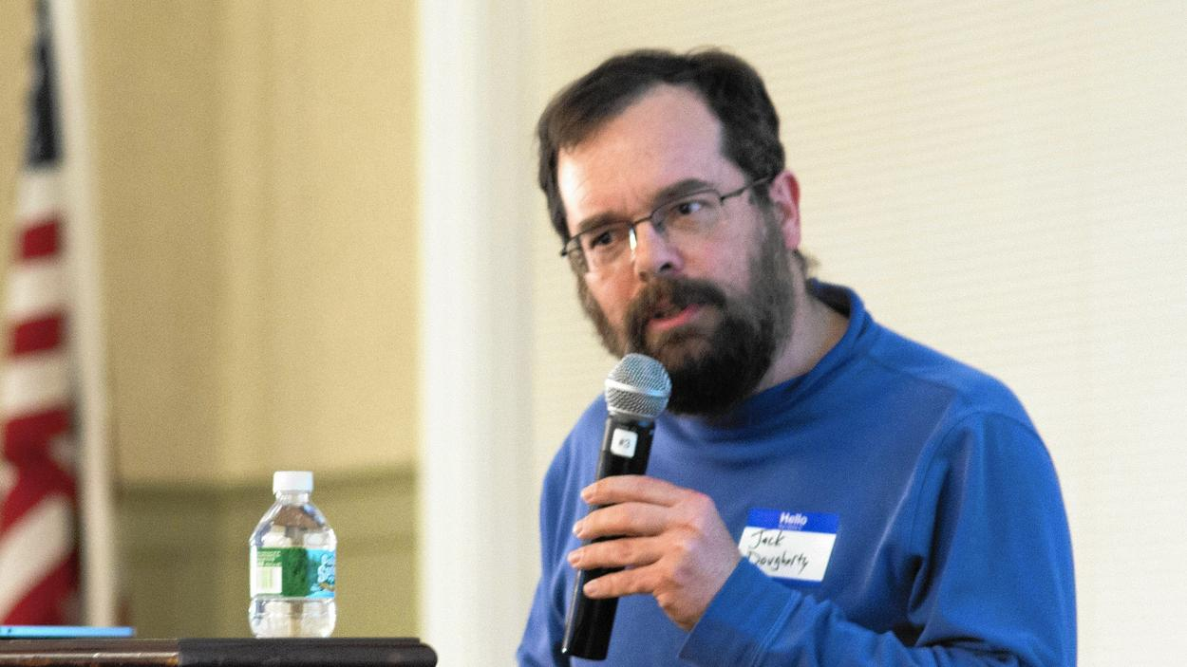

Trinity College professor Jack Dougherty presented research on how the area's housing became segregated

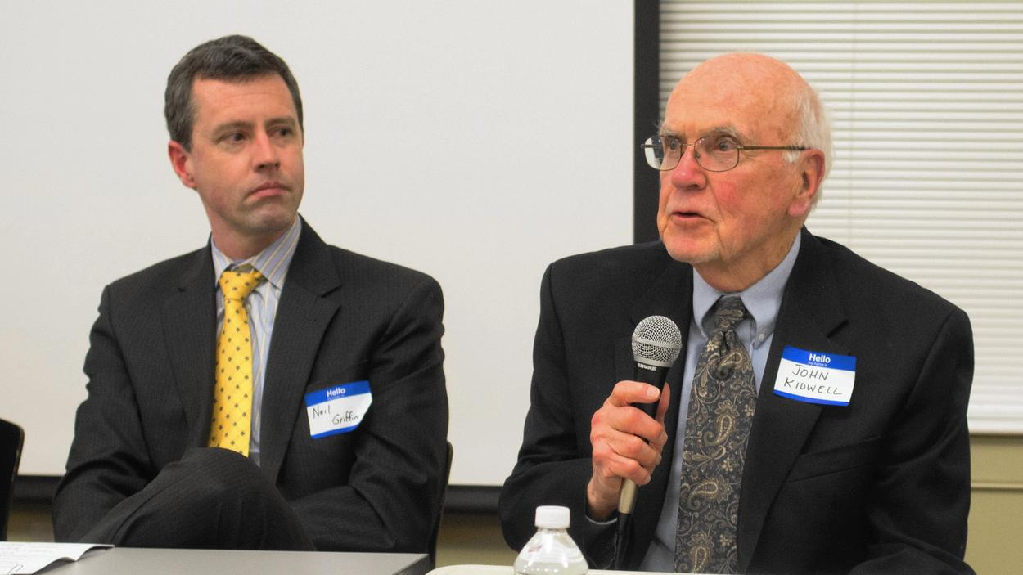

Glastonbury Housing Authority Executive Director Neil Griffin (left) looks on as Glastonbury resident John Kidwell talks about the origin of the Naubuc Green housing complex.

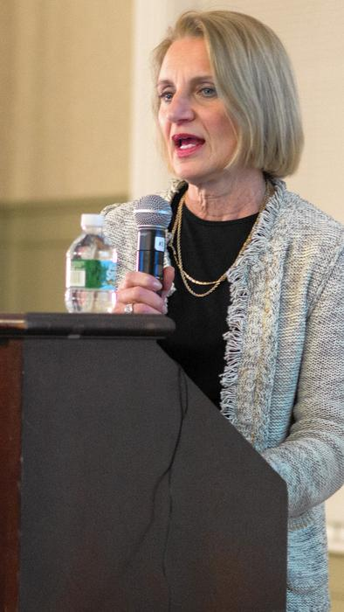

Connecticut Department of Housing Commissioner Evonne Klien said that people need to elect officials who will make the changes they want to see happen.

