Discussion On School Diversity Held In Glastonbury
By Steve Smith
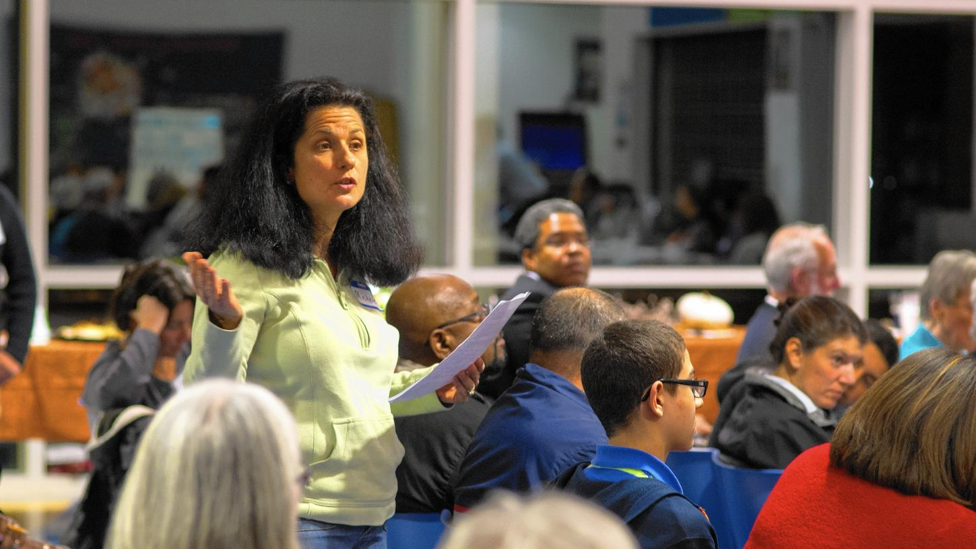
Michele Mudrick, a mother of two from Glastonbury, said the town's schools should include many more Open Choice seats, when she spoke at a Community Conversation on School Diversity hosted by the Glastonbury Martin Luther King Community Initiative on Nov. 16.
Why aren't Glastonbury schools more diverse? That wasn't necessarily the question intended to be asked at the Community Conversation on ethnic diversity in schools, hosted by the Glastonbury Martin Luther King Community Initiative on Nov. 16 at the Glastonbury-East Hartford Magnet School, but according to some it was the proverbial elephant in the room.
A panel discussion was led by moderator Phillip Tegeler, Executive Director of the Washington-based Poverty and Race Research Action Council and one of the attorneys who litigated the Scheff vs. O'Neill case.
Tegeler said that in his research, Hartford has become a model for other cities across the country with its level of integration. While other states' schools are becoming less integrated, Connecticut is heading in the opposite direction, because of the Scheff plan.
"[Hartford] is kind of a national treasure, in a sense, because it's showing other states what they can do," he said. "We should all be proud of this and work to preserve and grow it."
Included in the panel were Glastonbury and Capitol Regional Education Council officials, as well as parents of Open Choice students and students themselves.
Mary Jane Bezwares, a Hartford mother of three children – two of whom attend school in Wethersfield said her children were welcomed and have thrived in Wethersfield, but faced barriers when trying to take part in extracurricular activities.
"Wethersfield charges for everything…and they come at a hefty price," she said. "Hartford residents have to pay more, because we were not considered Wethersfield residents. We had to pay 15 to 20 dollars more."
Kim Bobin – Family Liaison for Open Choice Program in Wethersfield – was contacted by Bezwares and fought for and won equality in the pricing.
"A lot of times I find that a parent may ask a question and get a 'no,'" Bobin said. "My job is to find out the process to get a 'yes.'"
But Glastonbury's relative lack of diversity in schools became the crux of the conversation, especially when members of the audience chided Glastonbury schools to do better.
"The program's not growing fast enough," Tegeler said of Open Choice seats in town. "We're not meeting the needs of kids in Hartford who want to come into these schools. Glasotnbury, of the 22 towns in the region, had around 1-percent – the lowest participation rate of any district. How can we get Glastonbury to move up, over time, to some of the other districts in the region?"
Glastonbury Board of Education Chair Susan Karp said that the Board always has a lengthy and deliberate discussion about its Open Choice seats, and that it did increase them for this year in kindergarten and first grade.
"We look at what we can provide for the student, as well as what we need to provide for our students here, and we make the best decision," Karp said, adding that she felt the board will again consider increasing Open Choice seats and that ABC and other programs, including its Vocational Agriscience program, which is open to students from several surrounding towns, including Hartford.
Glastonbury Superintendent Alan Bookman echoed those thoughts, and said that the district has trouble opening more seats, because of the large amount of the town's population that consists of families who move to Glastonbury so their children can attend the schools there. He added that Glasotnbury has been a big supporter and participant in the magnet school programs, particularly when building the Glastonbury-East Hartford Magnet School.
"We have been a supporter of magnet schools from the beginning," Bookman said, adding that while the district wants diversity, the Open Choice seats have been concentrated at the younger grades, because it has been shown to have a greater benefit for the younger students.
"What we find is that students coming into kindergarten, through Hartford, do not have the same advantages as Glastonbury students," Bookman said, "adding that the monies received by the district for the Open Choice students are used for tutors to "beef up the skills" for kindergarteners who didn't have pre-K and other programs.
Michele Mudrick, a mother of two students in the Glastonbury school system, said that the district definitely needs more diversity. She said that (using 2012-13 numbers) 79.6-percent if students at Gideon Welles School are white, and only three there are in the Open Choice program, and only 6-percent of the staff are minorities. At Smith Middle School, 80-percent of students are white, with just over 3-percent of staff listed as minorities. Seven students at Smith are part of Open Choice, and 11 at GHS.
"Clearly, the records show that diversity is not one of Glastonbury Schools' strengths," Mudrick said, adding that she is disappointed that the district has less than one-percent of its students in the program, while other similar towns, such as Avon, have as much as 3-percent or more.
"Open Choice is a win-win for everyone involved," Mudrick said. "Glastonbury is missing out on the benefits of integrated education. It's very beneficial for children to learn in integrated settings. It's very saddening to learn we're not capitalizing on this. I feel that it's a disgrace that there are thousands of students on the waiting list who want to come here, and we are not accepting them."
Bookman said that part of the reason teacher diversity is low is because minority teachers are more –attracted to more-diverse school systems.
"We are doing everything we can," Bookman said. "We try to attract teachers of color. It's very hard to keep those particular teachers when we recruit them and they do come to Glastonbury. Part of the reason is, very often, they are looking for a community that has more diversity [where] they are helping more students. I wish we could do better."
"There's a mindset that we have to look at," another attendee said. "It's like a vicious circle. If you bring in more minorities, then maybe more minority teachers might want to come to your district. It's like a paradox. One side says 'Yes, yes, yes.' The other side says, 'No, no, no.' It may be that side that's like a vanguard, that wants to keep things like it is. That's the elephant in the room."

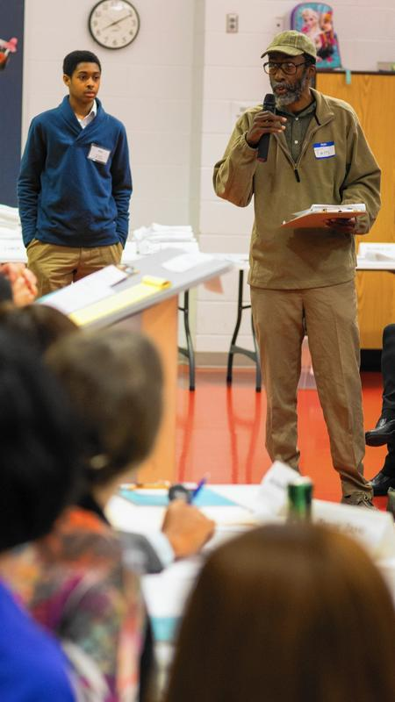
Tom Stringfellow, a parent from Manchester, who said he has been advocating for school diversity for years, said that residential segregation is part of the problem, and needs to be discussed.

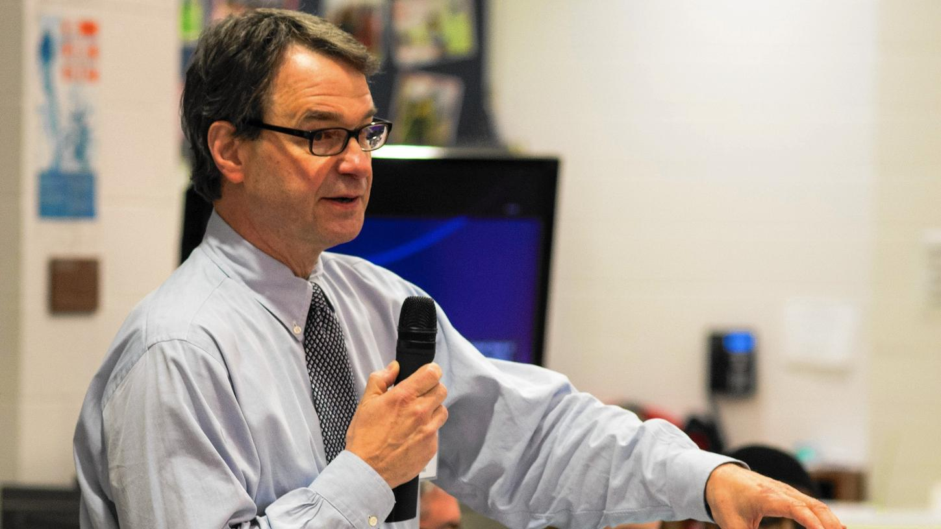
Discussion moderator Phillip Tegeler said Glastonbury should be able to add more Open Choice opportunities for students.

Mary Jane Bezwares, a mother from Hartford, said her children have benefitted from going to school in Wethersfield
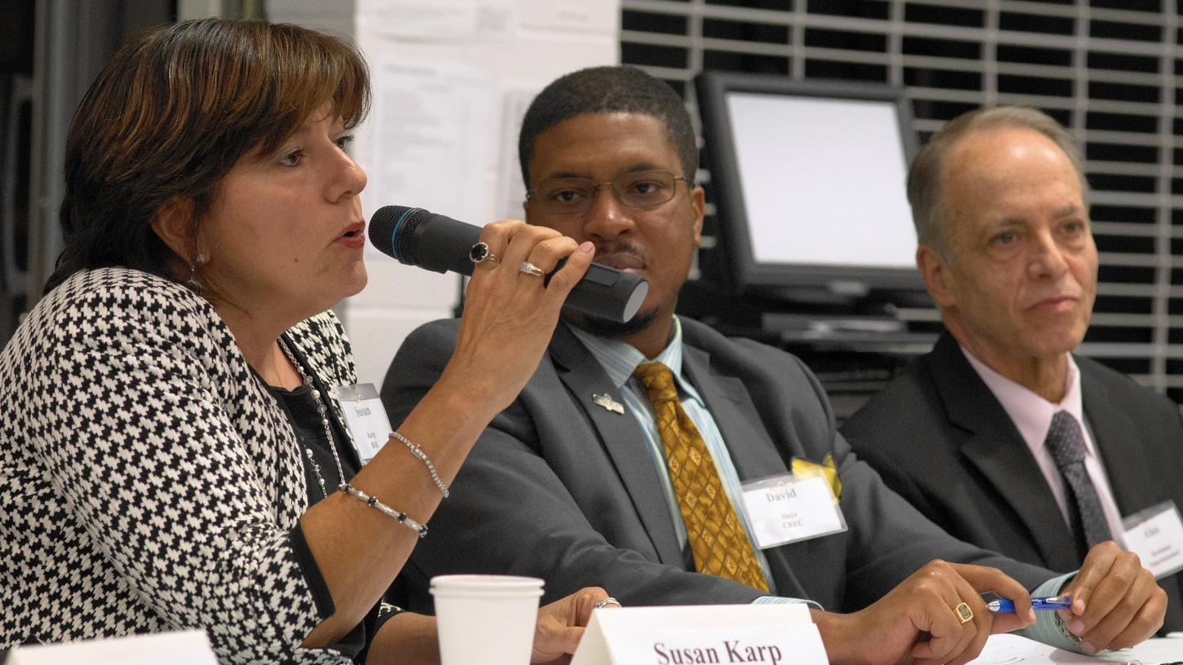
Managing Director of the Hartford Region Open Choice Program David Daye (center) and Glastonbury School Superintendent Alan Bookman look on as Board of Education Chair Susan Karp talks about the board's process of deciding how many Open Choice seats to add.
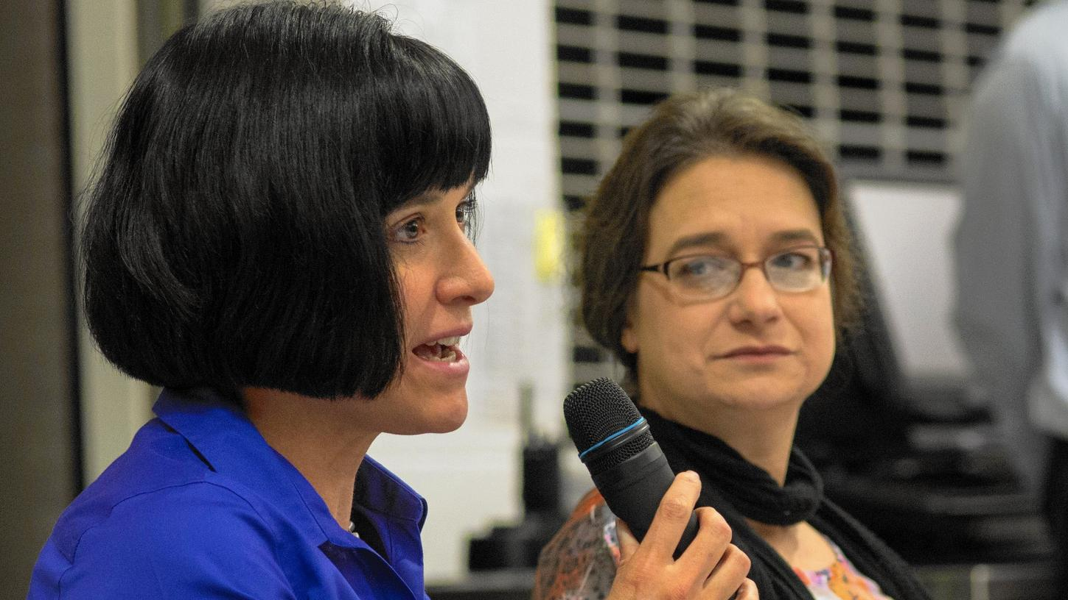
Kim Bobin, a family liaison for Open Choice, said implicit bias needs to be addressed with open, honest communication.

