Racial inequities do exist in juvenile justice system
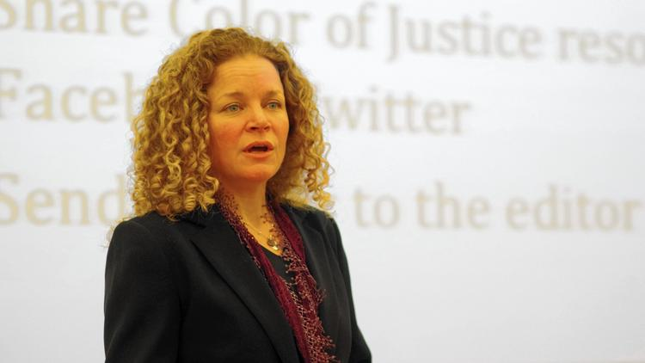

Lara Herscovitch, the Deputy Director of the Connecticut Juvenile Justice Alliance, lead the presentation and discussion
By Steve Smith Reminder News
Florence Hull, a former Kenyan diplomat, who has lived in many countries around the world and moved to Glastonbury in November of 2013, shared a story about how she experienced racism when she first joined her church here in Glastonbury, during a Community Conversation titled "The Color of Justice: The Search for Solutions," hosted by the Glastonbury Martin Luther King Community Initiative on April 9.
The event focused on the juvenile justice system, and how there is inequality along racial lines as to how youth in Connecticut are treated by the judicial system. The main presenters for the evening were Deputy Director of the CT Juvenile Justice Alliance Lara Herscovitch and Isabel Alvarez, court planner at the Court Support Services Division Training Academy.
The discussion centered on the film produced by CPTV called "The Color of Justice," which showed the disparity between what happens to black teens as opposed to white teens in the state's justice system. The 30-minute version of the film was shown.
"We know that kids of color are more likely to enter the juvenile justice system than their white peers," Herscovitch said, adding that skin color, and not income level or geography, has been proven to be the reason why this happens.
Alvarez said that there are several myths about why this is happening.
"If they commit more crimes, they're poor, or they live in cities," she said. "None of that is true. People of color are treated more harshly, not because of their actions. Children of color do the same things their white peers do, but are treated more harshly."
Connecticut data shows that black children are five times more likely to be arrested in schools than white children. Hispanic children were three times more likely.
Attendees were shown several photos of young people and asked to shout out their first impressions. It was later revealed that the same teen was shown twice, each time wearing different clothing and a different expression, and eliciting widely differing responses, which revealed that people do make judgments based on appearance.
"You have to be careful judging a book by its cover," Herscovitch said. "When we're talking about young people, there are all kinds of behaviors caused by all kinds of feelings – what's happening on that day and what mood a person might be in, especially when we are in decision-making positions with the authority to impact their life, school career, and so on."

Herscovitch said one of her main points is that diversion programs are more effective at keeping a young person on track than arrests, records and possible detentions.

"It's not about a free pass," she said. "We want to hold young people accountable for misbehavior. We want to actively steer them toward success. There are ways to do that that are outside of the judicial system that are more effective, and luckily, we have lots of research in this country that proves that. They also happen to be a lot less expensive."

Glastonbury Police Chief David Caron said he was glad to come and discuss the topic.

"Juvenile justice, and anything involving youth in our community, is very high priority for us," Caron said, adding that Glastonbury has a total of seven youth officers on its Youth Unit.

During the open discussion at the end of the event, several members of the audience spoke about their encounters with racism.

Hull said that people shouldn't be afraid of the police, but of other people in the community, because prejudice is still, unfortunately, prevalent. Hull explained that she attended a new church in Glastonbury, and was asked to register at the welcome desk. A woman at the desk told her she was joining the church at the right time, because the church was in need of a new cleaning lady.

"I thought about what I should say to her, and I often default to being a diplomat, because that's my training for all these years, so I said to her, 'The woman who cleans my house may have some extra time, so I will let her know," Hull said. "
Herscovitch said there are two kinds of bias in play; system bias – or policy and practice that is specifically targeting a group of people – and implicit bias.

"To be human is to carry implicit bias," she said. "It's about making sure that our conscience gets aligned with our values, so that any of our biases aren't negatively impacting our behavior, especially if we are interacting with our young people in our system."

Herscovitch said there is also a rush to treat youth behaviors as criminal that could be mitigated otherwise. She gave an example of an incident that happened recently in an urban Connecticut school. A young man, one of the school's star football players, appeared to be having a meltdown of some kind and was punching lockers and throwing a tantrum. Adults tried to intervene, but were escalating the situation. A school resource officer was called, but the new superintendent came on the scene first and spoke to the young man about what was going on. The student said his outburst was in response to a new article of clothing that had something spilled on it.

The administrator offered to get the item cleaned, if the student would calm down. "Incident over," said Herscovitch. Herscovitch said had the incident been handled by the resource officer, who may not be a fan of positive youth development, it might have gone another way and that once a kid has four or five charges like that, the student often ends up at a probation officer's desk.

The audience was provided with action steps to take, going forward. Attendees were encouraged to follow the Connecticut Juvenile Justice Alliance on social media on its website at http://www.ctjja.org, or to send letters to the editors of newspapers. They could also attend local interagency service teams, or become an advocate for demanding that local towns have a Memorandum of Understanding that defines police roles in schools.

"You can continue the conversation," Alvarez said. "You can host a conversation like this on your own, or start a film club. The real work must happen on the local level. You can advocate locally and get involved with youth programs."

For more information, visit http://glastonburymlkci.org.

