Young Voices Highlight Martin Luther King Celebration
By Steve Smith
Dr. Martin Luther King, Jr. made Sheff vs. O'Neill possible, according to Stacy-Ann Wallen. Wallen is a Hartford native and graduate of Hall High School in West Hartford (now a UConn freshman studying nursing) who benefitted from the Open Choice program that grew from the landmark Sheff decision.
Wallen was one of several presenters at the Glastonbury Martin Luther King Community Initiative's annual Martin Luther King, Jr. Celebration on Jan. 18. This year's event focused on young people's voices about King, civil rights, and the current state of how Americans are dealing with race and social issues.
Wallen read a speech she had created in high school, about her experiences and how they relate to King's message.
Wallen said that while, sadly, many of King's dreams are not yet fulfilled, some progress has been made, including opening doors for students like her.
"I am grateful for the opportunity his fight has afforded me," she said. "I was truly blessed to have the privilege to attend schools where I was accepted, loved and included as my white counterparts. Because of Dr. King's tenacity to break down the walls of discrimination, I was able to walk through the same hallways, drink from the same water fountain, eat in the same cafeteria and interact with my white peers without being handcuffed, beaten, thrown in jail or killed."
Wallen also notes Elizabeth Horton Sheff, mother of Milo Sheff, lead plaintiff in the case, for her work forging school integration.
"Her activism to cross boundaries and make a difference has given many minoritie students a favorable start in life," Wallen said. "Fortunately, I was one of the minority students bussed daily into suburban schools."
Wallen said that while on several occasions, she was the only black student in class, she never felt discriminated against.
"Instead, I was included," she said. "I had a very good relationship with my peers, and gained the respect of my principal, teachers, staff members and students."
"I believe his words are still relevant today," Wallen said, adding that King's dream –"…that one day little black boys and girls will be holding hands with little white boys and girls" applies to her, because that is how her education turned out.
Alfred Carter, retired Dean of Students from Manchester Community College, emceed the event, and said that King left a "broad and extended legacy," with the potential of even more impact on the community, which is represented by the youth who are furthering his message today –decades removed from his passing.
Among the other presenters was the Looking In Theatre – a social action troupe from the Hartford Academy of Performing Arts, who performed two scenes depicting modern racism among teens. In one scene, a young white man accuses a black classmate of stealing his phone, because "it made the most sense." In another scene, the same teen confronts his sister about befriending a hispanic girl.
"I just assumed all of her friends would be white," the character said.
The actors then answered questions, in character. Audience members chided "Brandon" played by student actor Eric Murphy.
"Do you feel superior?" one audience member asked.
"Not cool, Brandon," another said.
"Obviously, the point here is not to try say that his behaviour is correct," said Looking In Director/panel moderator Jonathan Gillman. "But, there are people who think like that, and behave like that. It's a way to put a human face on these things."
Three student films were shown, including one by Nicole Ellis of the CREC Journalism and Media Academy, about her experiences in an integrated school, and Don't Shoot I Can't Breathe, a music video about police brutality by Tyrese Hemmingway of the R.J. Kinsella Magnet School of Performing Arts. Hemmingway's film won the 2015 Reel Youth Hartford Film Festival Award for Best Performance.
Also shown was a film by Bandonlee Cruz, a graduate of the Watkinson School, called, "What is Hartford?" which took a decidedly negative answer to the question it poses. Cruz, who responded to questions about Hartford's future via pre-recorded video, said that while he sees a a difficult future for people of color, people in poverty, and transgendered people, but he hopes for a different one.
"I hope for a future of justice and peace," he said, "a future where black children, if shot down by police officers, the police will face prosecution – a future where Muslims will not get randomly selected at airports… this is the future that many, many people want."
Carter said King accepted the challenge and the responsibility for action, and that the young presenters have lived up to King's legacy, including Wallen.
Wallen said that she felt in good company.
"It was very powerful," Wallen said of the event. "It was really good to see the other young people's presentations and see what their perspective was on it. It was intriguing and so beautiful."
For more information, visit www.glastonburymlkci.org.

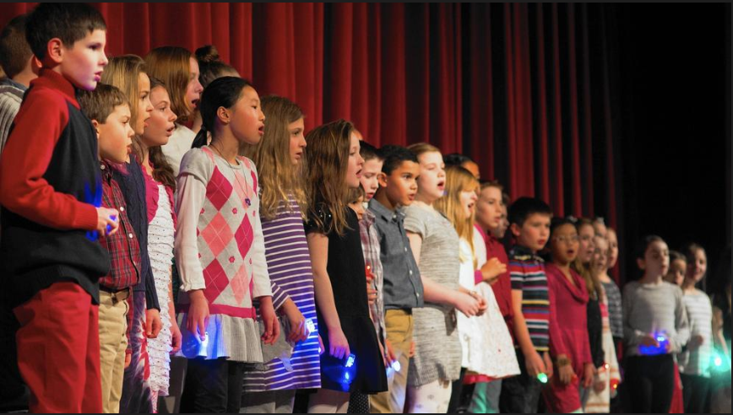
The Naubuc School Early Bird Choir performed "We are Marching", "Wade in the Water", and "We are the World".
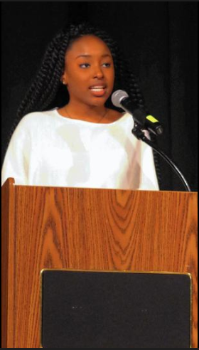
Hartford native Stacy-Ann Wallen explains how Dr. King's efforts helped her attend school in West Hartford via the Open Choice program.
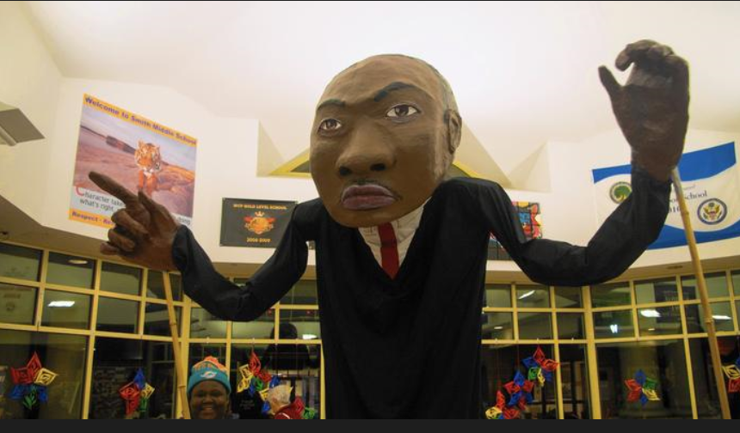
A giant representation of Dr. Martin Luther King, created by young people from the Hartford Catholic Work, an after-school tutoring, art and conflict resolution organization, greeted attendees at Smith Middle School.
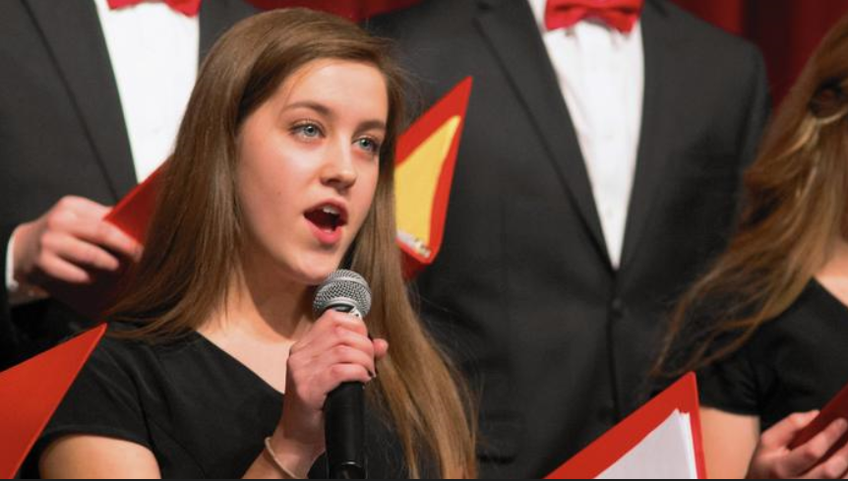
Hannah Stetson performs a solo with the GHS Madrigals.
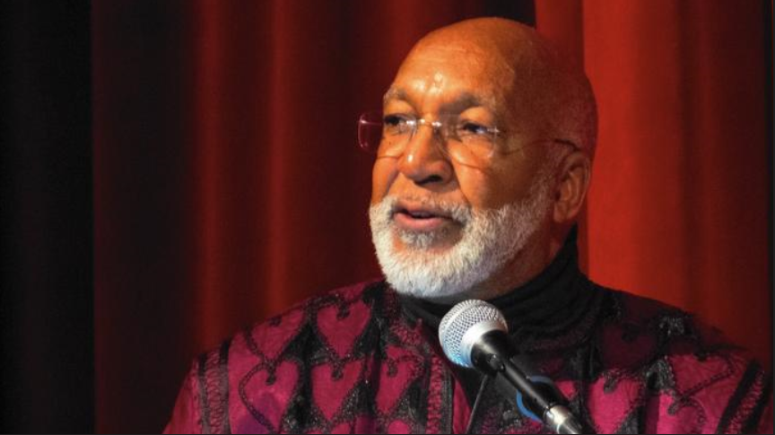
Dean Alfred Carter, emcee of the event, said that he has no answers to the problems and concerns of the world, but he tells people that there is always hope for the future.
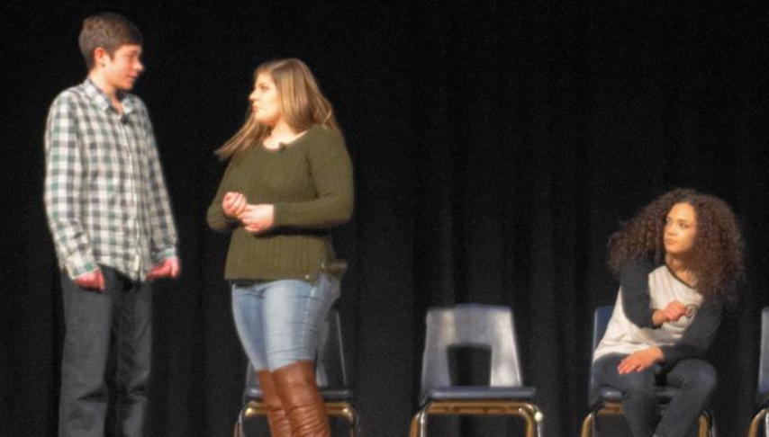
Student actors from the Looking In Theatre from the Greater Hartford Academy of Performing Arts, play a scene in which one teen acts very racist.
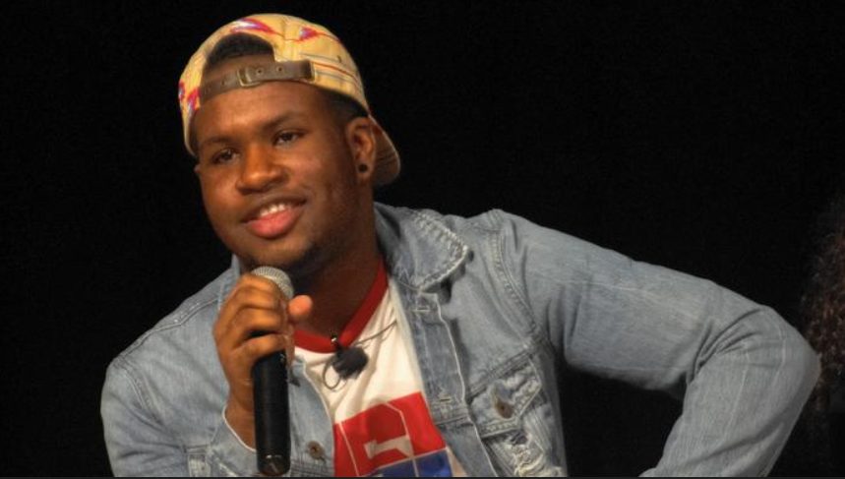
Raheem Brooks, a student in the Looking In Theater from the Greater Hartford Academy of Performing Arts, explains why his character felt discriminated against.
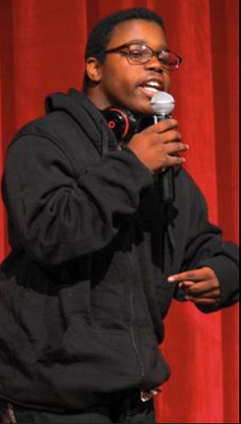
Tyrese Hemmingway, performed an original rap piece, after showing a film he created called 'Don't Shoot, I Can't Breathe.'

